Lengthened cold stratification improves bulk whitebark pine germination

Nathan Robertson, Kent Eggleston, Emily Overton, and Marie McLaughlin
Nathan Robertson is Horticulturist, USDA FS Coeur D’ Alene Nursery, Coeur D’ Alene, ID 83815; email ndrobertson@fs.fed.us.
Kent Eggleston is Horticulturist, USDA FS Coeur D’ Alene Nursery, Coeur D’ Alene, ID 83815; email keggleston@fs.fed.us.
Emily Overton is SCEP Trainee, USDA FS Coeur D’ Alene Nursery, Coeur D’ Alene, ID 83815; email overtonec@gmail.com.
Marie McLaughlin is Seed Orchard Manager, USDA FS Sandpoint Ranger District, Sandpoint, ID 83864; email mmclaughlin01@fs.fed.us.

<1>Abstract
Crucial to the restoration of whitebark pine (Pinus albicaulis) ecosystems is the ability of forest managers to locate, propagate, and reintroduce viable, disease-resistant populations to these jeopardized systems. Currently, one of the most limiting steps in this process is the slow, labor-intensive, and expensive process of producing whitebark seedlings at forest nurseries. From a nursery production standpoint, whitebark seed dormancy is complex and more problematic that other western conifers. Although seedling culture has evolved and become more streamlined, overcoming seed dormancy is still a major challenge to efficient seed use and large-scale seedling production. Releasing seed dormancy through scarification and stratification needs to result in adequate and consistent germination percentages, and also needs to be practical and efficient at a restoration-production scale. This paper describes trials comparing germination percentages of whitebark seedlots grown under operational conditions at the Forest Service Coeur D’ Alene Nursery to determine the relative influence of seed source elevation and location, seedlot (collection) age, and 60 or 90-days of cold stratification. The results of these studies indicate that, given proper seed collection, handling, cleaning, and storage: 1) 90-day cold stratification results in significantly increased germination over 60-day treatment; 2) within the first decade of storage, seedlot age may not play as crucial a role in reducing germinative capacity as was previously thought; and 3) seedlot source geography may not have a strong enough influence on germinative capacity to merit altering seed use calculations or culture regimes for greenhouse production.

<1> Key Words
<1>Introduction
Whitebark pine, the sole North American member of the Cembrae pine subsection, faces restoration challenges unique among the western conifers. Chief among these challenges is matching the pace of recruitment with an unnaturally accelerated mortality rate. The species faces the triple-pronged threat of introduced disease (Cronartium ribicola), native pine beetle (Dendroctonus ponderosae) epidemics, and historically uncharacteristic fire regimes (Mahalovich and others, 2006). In the past several decades, much effort has been dedicated to identifying and securing seed from apparently disease resistant forest trees for the purposes of understanding disease resistance genetics and establishing seed banks for future seedling propagation and restoration efforts.
The success of such efforts hinges on the ability of tree nurseries to reliably germinate seed from various collections. The germination strategy of whitebark differs considerably from other western pine species. Most notably, in addition to a thick, hard seedcoat, which hampers imbibition, whitebark seeds have complex physiological dormancy release mechanisms (Riley and others, 2007; Tillman-Sutela and others, 2007). Because whitebark cone crops vary widely from year to year, and predation claims many of the nutrient-rich seeds, these mechanisms are presumably an adaptive strategy to delay the germination of dispersed seeds over the course of several years (Tomback and others, 2001). This seed banking strategy may help offset periodic cone crop and seedling establishment failures, and balance recruitment through time. At the same time, these seed dormancy and germination characteristics make uniform artificial germination of whitebark seeds very difficult to achieve.
Past practices for producing whitebark seedlings in nurseries evolved out of germination and growth strategies developed for western white pine (Pinus monticola) (Burr and others, 2001). However, stratification protocols for this species proved to be inadequate for whitebark pine, with its additionally complex dormancy mechanisms. Because of the difficulty of protecting, collecting, and cleaning whitebark seed, investment in collections is significant compared to other western conifers (Keane, and others, 2012). Due to this value, and the historically limited volume of seed being processed and seedlings being grown, very labor-intensive scarification and growing techniques have been used in an attempt to maximize the productivity of a given seed collection. These processes have included various chemical scarification regimes, hand- or machine-knicking individual seeds to disrupt the seed-coat integrity, germinating seeds in artificial germinators, hand-transplanting individual germinants when radicals appeared, and re-stratifying un-germinated seeds to produce additional germinant flushes (Gasvoda and others, 2002; Pitel and Wang, 1990; Wick, and others, 2008).
It is possible, through a combination of stratification, scarification, and highly controlled environmental parameters, to achieve nearly 100% germination of mature, viable seeds (Riley and others, 2007; McCaughney, 1992). However, replicating such conditions on the scale needed for mass seedling production for the purpose of restoration plantings has continued to be very problematic for nurseries, and at times prohibitively expensive (Eggleston, 2012). These germination challenges, along with the slow growth of whitebark seedlings compared to other western conifers, has resulted in prices double or triple that of comparable products for other species (Eggleston, 2012). Efforts to streamline seedling culture have increased mass production efficiency tremendously (Eggleston, 2012). Still, overcoming low, erratic, and latent germination in whitebark seed at a large scale continues to be problematic.
At the Forest Service Coeur D’ Alene Nursery (CDA Nursery, Coeur D’ Alene, Idaho), whitebark seedling production has increased steadily in the past decade, and production levels are now near 200,000 seedlings per year (Eggleston, 2012). At this level, hand-knicking and hand-transplanting are logistically and economically impractical, so new methods must be developed to ensure adequate germination with a minimal investment of time and labor. Prior to the 2012 growing season, the CDA Nursery whitebark seed treatment protocols consisted of a 30-day warm strat, followed by a 60-day cold strat, after which seeds were scarified in a rotary drum sander (Missoula Technology & Development Center (MTDC)) (Gasvota and others, 2002) for three hours. (Past trials at CDA Nursery have indicated that sanding beyond three hours does not increase germination [unpublished data]). This dormancy release treatment, in combination with direct sowing, has allowed the CDA Nursery to produce large numbers of restoration seedlings, while avoiding the costs of hand-knicking and hand-transplanting. Unfortunately, germination percentages using this method have historically ranged from 13-75% (Eggleston, 2012). This wide range, coupled with the regular incidence of significant numbers of latent germinants, indicates that seed dormancy mechanisms were not entirely overcome, and/or that other factors influencing germination were at play.
If whitebark pine seedlings are to be produced in large quantities for the purpose of restoration plantings, nursery practices must be aimed at overcoming the complications associated with seed dormancy. Seed waste must be minimized by more fully realizing germinative capacity, while simultaneously avoiding laborious and expensive processes such as altering growing regimes to accommodate significant latent germination. In an effort to avoid seed and labor waste in future whitebark crops, we conducted a study comparing the current CDA Nursery stratification regime to one with an extended cold stratification treatment. We also considered potentially influencing factors, such as seed source and growing schedule. These studies were conducted in the 2011 and 2012 growing seasons at the CDA Nursery.

<1>Materials, Methods, and Treatments
Studies were performed in conjunction with operational whitebark seedling production for National Forest and National Park System clients at the CDA Nursery. In total, 25 operational seedlots were sown, representing all six of the USFS Northern Rockies whitebark seed zones (Table 1). Four of these seedlots had comparable sowings in 2011 and 2012; the others were sown in the 2012 growing season only. Two studies were conducted using germination data collected from these operational (client-requested, large-volume nursery stock order) whitebark sowings.
The first study was designed to compare germination under a single stratification regime using variations in seed source and growing schedule as factors. Namely, seedlot age, source elevation, seed zone, and sowing date were considered as potentially influencing germination rate. Only lots sown during the 2012 growing season were considered in this trial. The second study compared germination rates of four seedlots using differing stratification protocols (60 or 90 days cold stratification) sown in 2011 and 2012.
For both studies, operational whitebark seedlots collected from various locations and years were cleaned, stored, scarified, and sown under standard operational conditions for whitebark seedling production at the CDA Nursery. Seed was cleaned to 98% or better purity, and 90% or better seeds filled. All seed was warm stratified at 18°C (65°F) for 30 days, then cold stratified at 0.5-1.7°C (33-35°F) for either 60 (2011 sowings) or 90 (2012 sowings) days. Following stratification, seeds were surface dried and scarified using a rotary drum sander by sanding 0.25 lbs (.11 kg) of seed at a time for three hours, then washing to remove dust. Seeds were immediately sown into containers for operational seedling production by inserting the seed below the media horizon so as to be completely covered with moist media, but no more than 0.25 in (.64 cm) deep, and covered with no more than 0.25 in (.64 cm) of inert top-dressing. Containers were placed in greenhouses heated to 18°C (65°F), with upward daytime temperature fluctuated minimally, with a cooling set-point at 24°C (75°F). Due to the similar and controlled climate parameters in the greenhouses, differences in germination conditions between the 2011 and 2012 growing seasons were assumed to be non-significant for the purposes of this trial. Media was kept moist throughout the germination and growing process.
Seeds were sown at various dates ranging from January 19 to June 7 of 2011 and 2012. Final germination counts were taken in early July 2011 and late August 2012. Containers were randomly selected from within a large seedlot block, and seeds (germinated or not germinated) counted as individual replicates. Seedlot sample sizes ranged from 7%-100% of seeds sown, with no less than 392 seeds being sampled for any one lot.
Germination data was compiled and statistical analyses were performed to assess the influences of potential variables on germination performance. Only data from seedlings grown in 2012 were used to assess potential influences of seedlot age, sowing date, and elevation. Least squares regression analyses were used to determine the relative influence and importance of each variable on germination performance in each grouping. Germination percentages for each lot were used as data points and tested for seed zone significance using lot germination averages in an analysis of variance. For the four seedlots sown in both 2011 and 2012, the Pearson’s chi square test was used to compare germinative performance and determine significance. Each seed lot was analyzed using a separate test.

<1>Results and Discussion
In the first study, regression analyses were used to determine the effect of seed source variables and sowing date, rather than traditional significance tests, due to large sample sizes (n>391 for each lot tested). Regression results for seedlot age (R²=0.046) (Figure 1), sowing date (R²=0.053), and elevation (R²=0.10) indicated that these factors held relatively little influence on germinative performance in this trial. Seed zone did not show a significant influence on germination either (p =0.73). In the second study, the results of the a Pearson’s chi square test indicated significant differences in germination between those seeds cold stratified for 60 days and those cold stratified for 90 days. Each of the four seed lots tested showed significantly increased germination when subjected to the longer stratification regime, with germination more than doubling in two of the lots (Figure 2).
It is to be expected that differences in seed collections result in differing germination rates among seedlots. Seed cleaning, handling, storage condition, and storage longevity also influence germinative capacity post-collection (Tomback and others, 2001). To what degree variations in collections and seedlot age influence germination in whitebark pine seed has yet to be determined. From a nursery operational standpoint, these factors are only important if they significantly influence germination rates at the time of seedling production. For the seedlots used in the first study of this trial, none of the source related variables proved to have a strong determining influence on germination. Based on this observation, seed: seedling ratios for whitebark pine are not likely be adjusted to accommodate small influences on germination arising from differences in source elevation or seed zone.
Germination is directly correlated to sowing date in an outdoor growing facility due to changing environmental conditions. However, in a greenhouse environment with artificially controlled light, moisture, and temperature, sowing date should not influence germination. This proved to be true in our trial. Of more importance is considering the time required to produce a containerized whitebark seedling, even under optimal growing conditions, and adjusting the planting date accordingly.
All conifer seed has a limited shelf-life, although it varies considerably from species to species. Historically, much of the whitebark seed at this facility has been sown for seedling production within several years after collection, for two reasons. First, whitebark seed collections have barely kept pace with seed use for seedling production and banking, which resulted in minimal long-term storage. Second, it has been the experience of personnel at this facility (Burr and others, 2001) that whitebark has very limited storage longevity, despite its considerable size and nutrient content. Most clients were encouraged to have their seed sown within 1-5 years of collection, to avoid viability losses in cold-storage. However, this assumption arose under older stratification, scarification, and germination protocols (Burr and others, 2001). Our results and others (Berdeen and others, 2007; McCaughney and others, 1990) indicate that seedlot age plays a much less significant role in reducing germinative capacity than was previously thought. Granted, seedlots held in cold-storage necessarily begin to lose viability at some point; and our sample represents primarily young seedlots (<4 years in storage) (Table 1). However, the strong germinative capacity of older seedlots in this trial (up to 9 years in storage) (Figure 1), leads us to reconsider the role of seedlot age in reducing germination. When cleaned to a high purity and percentage of filled seeds, whitebark seed may have considerable longevity, likely exceeding a decade in cold storage without considerable loss of germinative capacity. Furthermore, empirical observations of seedlots being grown at the CDA Nursery suggests an improvement in germination rates for seedlots held in cold storage for at least a year post-collection.
The second study in this trial revealed the importance of stratification length in obtaining high germination percentages in whitebark. Although similar trials have been conducted on a relatively small scale (Riley and others, 2007; Wick and others, 2008), these works were research-oriented, and used scarification and germination techniques not practical at an operational restoration scale. This combination of 90-day cold stratification and mass scarification resulted in higher and more consistent germination than has been seen before at this facility for operational whitebark crops (unpublished data). Because the two stratification groups were grown in separate years, it is possible that factors beyond those considered here influenced germination. However, as already discussed, greenhouse conditions and scarification regimes were unchanged between the two growing seasons. Theoretically, an additional year in cold-storage would have had no effect or a small negative effect on germination, and because all four of the lots used for the second study were collected in 2009, any storage influence would be shared equally amongst them. These factors fail to explain the significant increase in germination apparent in all four seedlots, which indicates that a 90-day cold stratification is instrumental in obtaining strong germination for direct-sown, restoration-level whitebark pine seedling production.
<1>Summary
Whitebark pine seedling production levels continue to rise at the Coeur D’ Alene Nursery, as forest managers are increasingly in a position to bolster recruitment in compromised stands using disease-resistant seedlings. At the production scale being seen now, original scarification and stratification methods are no longer economically viable, and waste of hard-won whitebark seed is not acceptable at these levels. In an effort to maximize germinative capacity without sacrificing production efficiency, dormancy release factors must be understood and overcome. Given proper seed collection, handling, cleaning, and storage, the results of these two studies indicate that: 1) 90-day cold stratification results in significantly increased germination over 60-day treatment; 2) within the first decade of storage, seedlot age may not play as crucial a role in reducing germinative capacity as was previously thought; and 3) seedlot source geography may not have a strong enough influence on germinative capacity to merit altering seed use calculations or culture regimes for greenhouse production.
Although cold stratification lengths in excess of 90 days become logistically burdensome at this facility, further study should be conducted to see if longer cold stratification periods result in higher germination rates. Additionally, more research will be needed to better understand true whitebark seed longevity in cold-storage, especially with regards to variant embryo maturity (Tillman-Sutela and others, 2008), and the potential positive effect of storing seed for at least a year post-collection. Seed managers and horticulturists at the Coeur D’ Alene Nursery will use this data and future studies to increase whitebark seed use and production efficiency, in an effort to better contribute to the restoration of this high-elevation cornerstone species.

<1>References
Berdeen J, Riley L, Sniezko R. 2007. Whitebark pine seed storage and germination: A follow-up look at seedlots from Oregon and Washington. In: Goheen E, and Sniezko R, technical coordinators. Proceedings – Whitebark Pine: A Pacific Coast Perspective. R6–NR–FHP–2007–01. Portland, OR: U.S. Forest Service, Pacific Northwest Region.
Burr K, Eramian A, Eggleston K. 2001. Growing whitebark pine seedlings for restoration. In: Tomback D, Arno S, and Keane R, editors. Whitebark Pine Communities, Ecology and Restoration. Washington (DC): Island Press.
Eggleston K. 2012. Personal communication. Coeur D Alene (ID): Greenhouse Horticulturist, USDA Forest Service, Coeur D Alene Nursery.
Gasvota D, Trent A, Harding C, Burr K. 2002. Whitebark Pine Seed Scarifier. In: Timber Tech Tips, Nov. 2002. USDA Forest Service, Technology & Development Program. 0221-2332-MTDC.
Keane R, Tomback D, Aubry C, Bower A, Campbell E, Cripps C, Jenkins M, Mahalovich M, McKinney S, Murray M, Perkins D, Reinhart D, Ryan C, Schoettle A, Smith C. 2012. A range-wide restoration strategy for whitebark pine (Pinus albicaulis). Gen. Tech. Rep. RMRS-GTR-279.: USDA Forest Service, RMRS.
Mahalovich M, Burr K, Foushee D. 2006. Whitebark pine germination, rust resistance, and cold hardiness among seed sources in the Inland Northwest: planting strategies for restoration. In: Riley L, Dumrose KR, LandisT, technical coordinators. Proceedings – Forest and Conservation Nursery Associations – 2005. RMRS-P-43, USDA Forest Service, Rocky Mountain Research Station, Fort Collins, CO, USA.
McCaughney W, Schmidt W. 1990. Autoecology of whitebark pine. In: Schmidt W, McDonald K, compilers. Proceedings – Symposium on whitebark pine ecosystems: Ecology and management of a high-mountain resource. Gen. Tech. Rep. Int-270. USDA Forest Service, Intermountain Research Station.
McCaughney W. 1992. The regeneration process of whitebark pine. In: Schmidt W, Holtmeier F, compilers. Proceedings – International workshop on subalpine stone pines and their environment: The status of our knowledge. Gen. Tech. Rep. INT-GRT-309. USDA Forest Service, Intermountain Research Station.
Pitel J, Wang B. 1990. Physical and chemical treatments to improve germination of whitebark pine seeds. In: Schmidt W, McDonald K, compilers. Proceedings – Symposium on whitebark pine ecosystems: Ecology and management of a high-mountain resource. INT-270. USDA Forest Service, Intermountain Research Station.
Riley L, Coumas C, Danielson J, Berdeen J. 2007. Seedling Nursery Culture of Whitebark Pine at Dorena Genetic Resource Center: Headaches, Successes, and Growing Pains. In: Goheen E, and Sniezko R, technical coordinators. Proceedings – Whitebark Pine: A Pacific Coast Perspective. R6–NR–FHP–2007–01. Portland, OR: U.S. Forest Service, Pacific Northwest Region.
Tillman-Sutela E, Kauppi A, Karppinen K, Tomback D. 2008. Variant maturity in seed structures of Pinus albicaulis (Engelm.) and Pinus sibirica (Du Tour): key to a soil seed bank, unusual among conifers? Trees-Structure and Function 22(2):225-236.
Tomback D, Anderies A, Carsey K, Powekk M, Mellmann-Brown S. 2001. Delayed seed germination in whitebark pine and regeneration patterns following the Yellowstone fires. Ecology 82:2585-2600.
Tomback D, Arno S, Keane R. 2001. Whitebark Pine Communities: Ecology and Restoration. Island Press, Washington, DC, USA.
Waring K, Goodrich B. 2012. Artificial regeneration of five-needle pines of western North America: A survey of current practices and future needs. Tree Planters Notes, Vol. 55, No. 2, 2012.
Wick D, Luna T, Evans J, Hosokawa J. 2008. Propagation protocol for production of container Pinus albicaulis Engelm. Plants (172 ml conetainers); USDI NPS – Glacier National Park, West Glacier, MT. In: Native Plants Network. URL: http://www.native plantnetwork.org (accessed 7 August 2012). Moscow (ID): University of Idaho, College of Natural Resources, Forest Research Nursery.

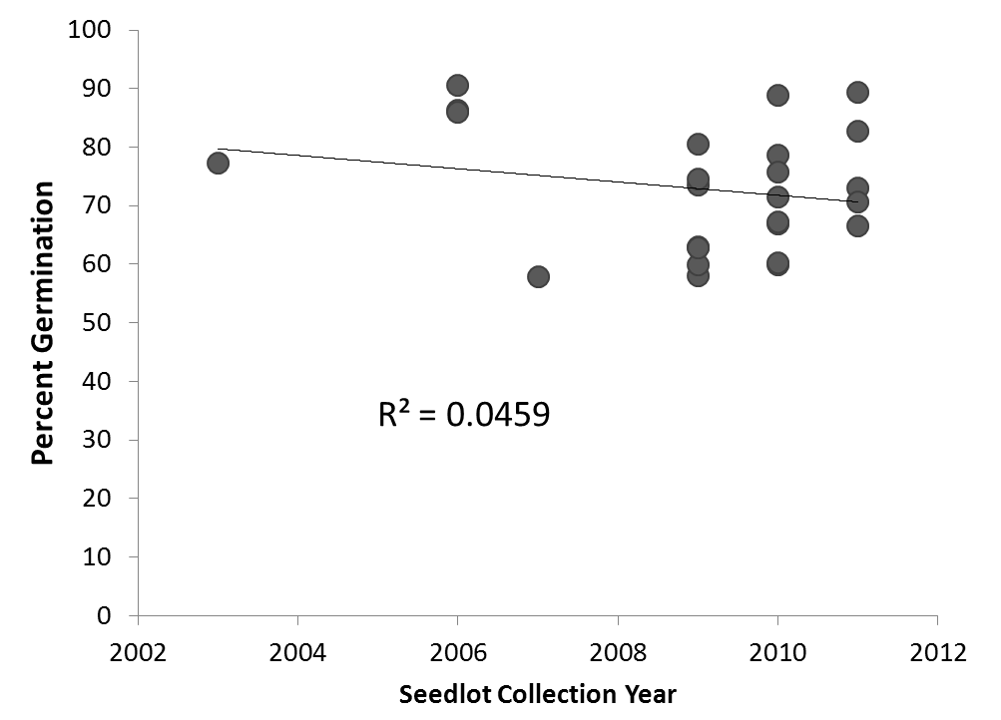
Figure 1. Percent germination by seedlot collection year (age) for lots sown in 2012, with 90-day cold stratification.

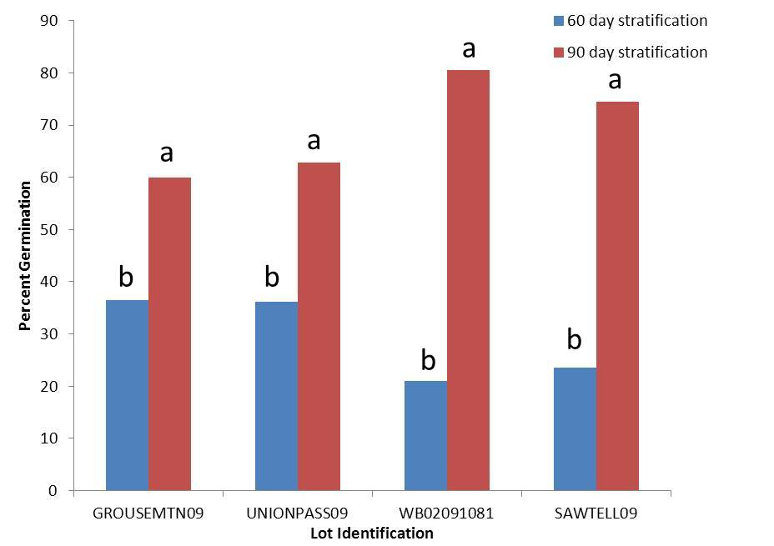
Figure 2 Effect of length of seed stratification on germination percentage. A chi square test was performed individually on each seedlot. Different letters denote significance at α=0.05.

Seedlot | Sow Year | Sow Date | Seed Zone | Collection Year | Elevation | Cold Strat Days | Germ %
GROUSEMTN09 | 2011 | 4-May | GYGT | 2009 | 6.2 | 60 | 36.5%
UNIONPASS09 | 2011 | 25-Jan | GYGT | 2009 | 6.5 | 60 | 36.1%
SAWTELL09 | 2011 | 2-Feb | GYGT | 2009 | 6.7 | 60 | 23.5%
WB02091081 | 2011 | 18-Mar | BTIP | 2009 | 8.1 | 60 | 21.0%
WBP2066 | 2012 | 7-Jun | GYGT | 2006 | 6.4 | 90 | 86.2%
WBP2067 | 2012 | 7-Jun | GYGT | 2006 | 6.0 | 90 | 90.6%
WBP2068 | 2012 | 7-Jun | GYGT | 2006 | 6.4 | 90 | 86.0%
NUMA | 2012 | 7-Jun | MSGP | 2010 | 6.5 | 90 | 59.9%
WBP1262-09 | 2012 | 4-Apr | GYGT | 2009 | 8.4 | 90 | 73.5%
PRESTONPARK07 | 2012 | 20-Mar | MSGP | 2007 | 8.7 | 90 | 57.9%
SURPRISE10 | 2012 | 20-Mar | GYGT | 2010 | 9.0 | 90 | 60.3%
BURKE09 | 2012 | 20-Mar | SKCS | 2009 | 9.3 | 90 | 58.0%
WHITECALF | 2012 | 20-Mar | MSGP | 2010 | 8.9 | 90 | 88.8%
WB14091093 | 2012 | 28-Feb | BTIP | 2009 | 8.1 | 90 | 63.0%
GROUSEMTN09 | 2012 | 26-Jan | GYGT | 2009 | 6.2 | 90 | 59.9%
RISINGWOLF | 2012 | 26-Jan | MSGP | 2010 | 9.0 | 90 | 71.4%
OLDMAN | 2012 | 24-Jan | MSGP | 2010 | 9.1 | 90 | 78.6%
BIGMTN11 | 2012 | 8-Feb | MSGP | 2011 | 6.9 | 90 | 89.3%
BETA_DESERT_NI | 2012 | 7-Jun | MSGP | 2011 | 7.0 | 90 | 73.0%
NAPA_SUNSET11 | 2012 | 9-May | MSGP | 2011 | 9.1 | 90 | 82.7%
HORNET11 | 2012 | 12-Apr | MSGP | 2011 | 6.2 | 90 | 70.6%
WB02091081 | 2012 | 23-Feb | BTIP | 2009 | 8.1 | 90 | 80.6%
DEADLINE11 | 2012 | 19-Jan | GYGT | 2011 | 10.0 | 90 | 66.6%
LITTLEJOE10 | 2012 | 20-Mar | SKCS | 2010 | 9.5 | 90 | 66.9%
VIPONDPARK10 | 2012 | 27-Feb | CLMT | 2010 | 8.6 | 90 | 67.3%
FREEZEOUT10 | 2012 | 4-Feb | CFLP | 2010 | 9.2 | 90 | 75.8%
WB03030092 | 2012 | 24-Feb | GYGT | 2003 | 6.3 | 90 | 77.3%
SAWTELL09 | 2012 | 23-Feb | GYGT | 2009 | 6.7 | 90 | 74.5%
UNIONPASS09 | 2012 | 1-Feb | GYGT | 2009 | 6.5 | 90 | 62.8%
Table 1 Whitebark pine seedlots sown in 2011 and 2012 for cold stratification length trial, with associated sowing dates, collection geography, seed zones, and germination percentages.

